Numerical Simulation of the Effects of Biodiesel Fuel Use on the Performance of the SWD 9TM 410 Engine

Rendri Julian Restiawan*, Muhammad Agung Bramantya, Willie Prasidha
Gadjah Mada University, Indonesia
Email: rendrijulian@gmail.com*, bramantya@ugm.ac.id, willie.p@ugm.ac.id

Keywords:  SWD 9TM 410 diesel engine; biodiesel B40; engine performance; exhaust emissions; CFD. |  | Abstract  The use of B40 Biodiesel as the main fuel in the Diesel Power Plant (PLTD) within PT PLN Nusantara Power UP Kapuas reflects the government's policy to reduce fuel oil imports and support the energy transition to renewable sources. In the SWD 9TM 410 engine at ULPLTG/D Siantan, the use of B40 Biodiesel provides significant changes to combustion characteristics, engine performance, and exhaust emissions. This study aims to model and analyze the combustion process of B40 Biodiesel using the Computational Fluid Dynamics (CFD) method through ANSYS Forte software with a multicomponent chemical mechanism approach. Simulation was carried out in the combustion chamber domain of cylinder 1 based on the actual geometry of the engine with output parameters in the form of peak pressure (Pmax), ignition delay (ID), rate of heat release (RoHR), indicated horsepower (IHP), temperature distribution, and formation of NOx and CO2 emissions. Validation was carried out using experimental data from engine operation tests. The simulation results show that the variation of the biodiesel mixture has an influence on combustion characteristics, engine performance, and the formation of exhaust gas emissions. B100 exhibited a 6.4% lower power output than B0 due to its lower heating value. In addition, differences in fuel characteristics result in variations in maximum cylinder pressure values, heat release rates, combustion temperatures, and NOx and CO2 emission concentrations at each loading level. Under the simulated conditions, the increase in the biodiesel fraction showed a tendency to produce lower combustion temperatures and NOx emissions than B0. The findings show that the fuel composition plays an important role in determining the combustion and emission characteristics of the SWD 9TM 410 diesel engine.

INTRODUCTION
The Diesel Power Plant (PLTD) within PT PLN Nusantara Power Unit Pembangkit Kapuas (UP Kapuas) is one of the generation facilities located in Pontianak City, West Kalimantan. The ULPLTG/D Siantan Power Plant Service Unit manages two types of power plants, namely PLTD and PLTG with a total Net Capacity (DMN) of 51 MW for PLTD and 30 MW for PLTG, so that the total DMN reaches 81 MW. In 2016, the Night Peak Load (BPM) in West Kalimantan's electricity system reached 320 MW, and is projected to increase to 680 MW by 2026, representing an increase of 112.5 percent in a decade. This condition requires all PLTD plants to continue operating to supply power needs so that blackouts do not occur, in line with the government's mandatory to achieve Net Zero Emissions (NZE) by 2060. (Atadashi et al., 2012; Bousbaa et al., 2024; Chen et al., 2023; Hoang, 2021; Khan et al., 2024)
In West Kalimantan Province, oil-fired power plants are still one of the backbones in supporting the electricity system. This is due to delays in the process of building large power plants such as coal-fired power plants and an increase in the number of customers every day (An et al., 2014; Cahyo et al., 2023; Knothe & Razon, 2017; Ma & Hanna, 1999; Mustak & Rahman, 2025). The geographical condition of West Kalimantan with a large area and a dispersed population also makes diesel plants a relatively more economical option than long-distance transmission infrastructure to central plants. The limited renewable energy sources that can be optimally developed in this region also make the government have to continue to rely on diesel plants to ensure the reliability of the electric power system (Ahmad et al., 2025; Heywood, 1988; Lapuerta et al., 2008).
The SWD 9TM 410 diesel engine is a medium-speed engine with a rotation characteristic of 500 rpm that is specially designed to use High Speed Diesel (HSD) fuel. This engine has a number of 9 cylinders with an inline engine configuration, a bore of 410 mm, a stroke of 470 mm, and a compression ratio of 15.2:1. This type of engine is a product of Stork-Werkspoor Diesel (SWD) from the Netherlands and belongs to the category of medium-speed engines that are popular in diesel power plants due to its ability to generate large torque, high thermal efficiency, and good durability for continuous operation over long durations. The SWD 9TM 410 engine is equipped with a direct-injection (DI) combustion system with a high-pressure multi-hole nozzle, a turbocharging system with waste-gate control combined with a charge-air-cooler (CAC) to increase the density of the inlet air and lower the combustion temperature (Demirbas, 2008; Ferguson & Kirkpatrick, 2016; Ganesan, 2012).
Along with the implementation of the mandatory biodiesel use program by the Ministry of Energy and Mineral Resources from 2024, all PLTD engines are now operating using B40 Biodiesel as the main fuel. This policy is part of the national strategy to realize Energy Security 2025 and support the achievement of the Net Zero Emissions (NZE) target by 2060. The use of B40 Biodiesel causes significant changes in fuel characteristics, so it has the potential to change engine operating parameters, performance, and exhaust emissions. Biodiesel has an internal oxygen content of 10-12 percent, a higher viscosity of 3.5-5.0 mm²/s compared to 1.9-4.1 mm²/s diesel, a lower calorific value of 37-40 MJ/kg compared to 43-46 MJ/kg diesel, and a higher setane value of 48-65 compared to 40-55 diesel.
The use of biodiesel has some positive impacts but also poses technical challenges. The positive impacts of the implementation of the mandatory biodiesel program include foreign exchange savings of USD 7.86 billion or Rp 124.28 trillion, an increase in the added value of CPO to biodiesel of Rp 17.68 trillion, the absorption of more than 12 thousand off-farm and 1.6 million on-farm people, and a reduction in emissions of 34.93 million tons of CO2e. Biodiesel with a mixture of FAME (Fatty Acid Methyl Ester) has more environmentally friendly chemical characteristics due to the presence of natural oxygen content that can increase combustion efficiency and reduce emissions of Carbon Monoxide (CO) and Hydrocarbons (HC). However, on the other hand, there are several aspects that are challenges in the operation of generating machines, especially PLTD due to the use of B40 biodiesel, including the phenomenon of deposit accumulation in the combustion chamber which is considered to be one of the factors that need to be reviewed for the long-term use of B40 Biodiesel.
Previous research has shown that the use of biodiesel and CPO fuels causes deposits to accumulate in the cylinder head, piston, valve, and nozzle. This condition greatly affects the overall performance of the engine because excessive deposit formation can clog the nozzle holes, reduce heat transfer in the combustion chamber, and shift the combustion process out of the combustion chamber, thus causing overheating in the exhaust manifold header. This is very relevant to the actual conditions in the field that cause load derating (load reduction) during the machine's operational process. In the Siantan ULPLTG/D engine, fuel migration using B40 Biodiesel technically has an impact on several aspects including operating parameters, engine performance and material service life. This condition requires an in-depth analysis of changes in combustion characteristics and engine performance due to the use of biodiesel.
Direct testing of the actual conditions on the SWD 9TM 410 engine is very risky to cause operational constraints and high costs. Therefore, numerical simulation based on Computational Fluid Dynamics (CFD) is one of the alternatives that is considered quite effective to study combustion characteristics in detail without interfering with operational processes in the field. Software such as ANSYS Fluent and ANSYS Forte are also able to simulate the phenomena of atomization, turbulence, chemical reactions, heat transfer, and emission formation according to research needs. ANSYS Forte is the only CFD simulation package for Internal Combustion Engines (ICE) that integrates ANSYS Chemkin-Pro's proven solver technology and is considered the standard for modeling and simulation of gas phase chemistry as well as surface chemistry. Forte is equipped with advanced Automatic Mesh Generation (AMG) technology, including Solution Adaptive Mesh Refinement (SAM) and geometry-based Adaptive Mesh Refinement (AMR) that are capable of producing high-accuracy simulation results.
Thus, this study is important to analyze the influence of biodiesel use on combustion characteristics, engine performance, and emissions through a CFD numerical simulation approach validated using actual operating data at ULPLTG/D Siantan. This research will provide understanding and scientific information about the combustion characteristics of the SWD 9TM 410 diesel engine in the use of Biodiesel, as well as contribute to the development plan of new and renewable energy policies in Indonesia, especially the percentage of biodiesel as an alternative fuel. In addition, this study can be a technical reference for evaluating the feasibility of using Biodiesel Fuel in diesel engines at PT PLN Nusantara Power, especially ULPLTG/D Siantan, as well as providing predictive data on engine performance, efficiency and emissions for the power generation industry in Indonesia that still uses Diesel Power Plants (PLTD).
Previous research has shown that the use of biodiesel has a significant impact on the combustion characteristics of diesel engines. Yang et al. (2022) found that biodiesel blends cause increased pressure in the combustion chamber to occur earlier as well as shorten the duration of combustion. Research by Chen et al. (2023) shows that the addition of biodiesel fuel ratios can increase the oxygen content of the mixture thereby improving the combustion process and resulting in an increase in peak pressure at medium and high loads. Cahyo et al. (2023) stated that the use of CPO in low-speed diesel engines caused a decrease in gross power of 14.43 percent, a decrease in peak combustion pressure of up to 20 percent, and a decrease in indicated horsepower by 7.44 percent.
Numerical research using CFDs in diesel engines has been extensively conducted to analyze the combustion characteristics of biodiesel. Numerical studies of diesel engines using ANSYS Forte show that the variety of biodiesel fuels has a significant influence on engine performance and emissions. Mustak and Rahman's (2025) research used ANSYS Forte for pilot injection timing optimization in dual-fuel engines, showing that CFD is able to predict combustion characteristics with high accuracy. Other research shows that increasing the biodiesel fraction tends to lower CO and HC emissions but increases NOx emissions under some operating conditions. These differences in results show that the characteristics of biodiesel are strongly influenced by the type of feedstock, engine operating conditions, and injection parameters.
Biodiesel has different characteristics than conventional diesel. The density of biodiesel ranges from 860-900 kg/m³, higher than diesel of 820-860 kg/m³. The kinematic viscosity of biodiesel at 40°C is 3.5-5.0 mm²/s, higher than diesel 1.9-4.1 mm²/s. The calorific value of biodiesel reaches 37-40 MJ/kg, lower than diesel 43-46 MJ/kg. The number of biodiesel setane is 48-65, higher than diesel 40-55. According to Turns (2012), NOx emissions in diesel engines are greatly influenced by high combustion temperatures, large cylinder pressures, and the presence of excess oxygen. The formation of NOx occurs through the thermal mechanism of NOx which comes from the reaction between nitrogen and oxygen in the air at high temperatures, generally above 1800 K. The main reactions include N₂+O → NO+N, N+O₂→NO+O, and N+OH → NO+H.

METHOD
This study uses a numerical simulation approach based on Computational Fluid Dynamics (CFD) with ANSYS Forte software. The combustion chamber geometry is made based on the dimensions of the SWD 9TM 410 engine with specifications: bore 410 mm, stroke 470 mm, cylinder volume of 62 liters per cylinder, compression ratio of 15.2:1, and injector hole number of 10 x 0.700 mm. Simulations are performed on a single sector of 36 degrees representing one of the ten nozzle holes of the injector for computational efficiency without compromising the accuracy of the results. Fuel modeling uses a surrogate approach with a multicomponent reaction mechanism. The meshing process uses cartesian mesh automatically decomposed with a minimum cell size of 6-10 mm, a target mesh of 50k-150k cells, and refinement in near-wall bowls, spray regions, and squish areas. Model validation was carried out by comparing the simulation results against experimental data from engine testing, including cylinder pressure curve (P-θ), maximum pressure (Pmax), start of combustion (SOC), and exhaust emissions. The simulation was carried out at an operating load of 50 percent, 75 percent, and 100 percent of nominal power with fuel variations of B0 (pure diesel), B40 (40 percent biodiesel), B50 (50 percent biodiesel), and B100 (pure biodiesel). The simulations were conducted using the RANS RNG k–ε turbulence model under constant engine specifications, with the thermal conductivity, density, and specific heat capacity of the cylinder wall assumed to be constant.

RESULTS AND DISCUSSION
CFD Model Validation
Model validation was carried out by comparing the numerical simulation results against experimental data to ensure that the CFD modeling was able to represent the actual combustion characteristics of the SWD 9TM 410 diesel engine. In the pressure curve validation, the average value of the cylinder pressure from the simulation was 16.09 bar, while the experimental data was 15.72 bar, with an error value of only 2.40 percent. The maximum pressure value (Pmax) of the simulation of 86.12 bar is close to the experimental result of 85.20 bar, with a relative error of 1.09 percent. The Pmax position also showed good alignment, occurring at 9°CA ATDC in the simulation compared to 10°CA ATDC in the experiment. This shows that the simulation model has been able to predict the maximum combustion pressure realistically and close to the actual condition of the engine. The Start of Combustion (SOC) in the simulation occurred at a pressure of 55.77 bar compared to 52.46 bar in the experiment, with an error of 6.60 percent, indicating that the combustion phasing had been fairly well represented.

Table 1. Pressure and Emission Validation Data
Parameters | Simulation | Experiments | Error (%) | Remarks
Pmax (bar) | 86.12 | 85.20 | 1.09 | Excellent
Average P (bar) | 16.09 | 15.72 | 2.40 | Good
CO₂ (%) | 12.99 | 11.84 | 9.71 | Pretty good
NOx (mg/Nm³) | 1129.46 | 1036.07 | 9.01 | Pretty good

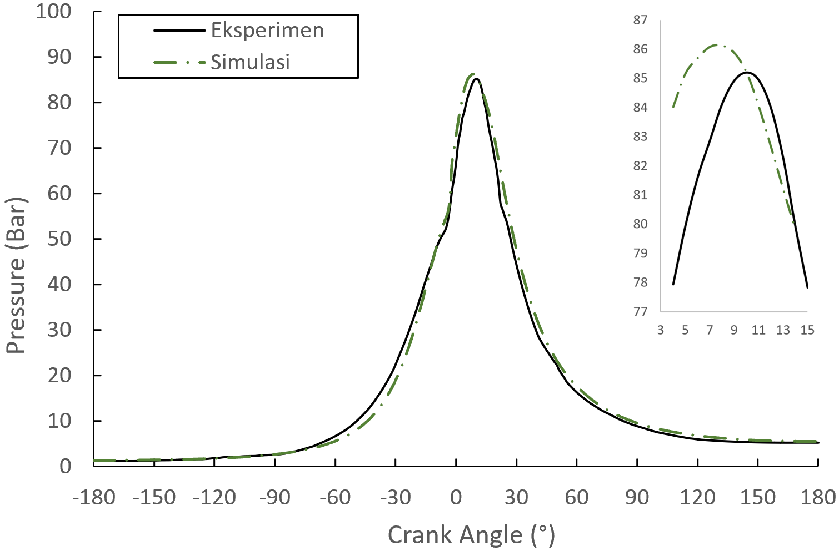
Fig 1. Experimental and simulated curves of cylinder pressure

Effect of Biodiesel Variation on Combustion Pressure
Combustion pressure analysis shows that the use of biodiesel exerts a significant influence on the cylinder pressure characteristics. At 100 percent load, B0 produces the highest maximum pressure of 86.12 bar, followed by B40 of 85.55 bar, B50 of 84.94 bar, and B100 of 79.03 bar. This difference is caused by the difference in the calorific value of fuel, where biodiesel has a lower calorific value than conventional diesel. The oxygen content in biodiesel of 10-12 percent helps the fuel oxidation process so that combustion becomes more perfect, but the lower calorific value causes less total heat energy produced. The rate of pressure increase in the B40 and B50 biodiesel mixtures still shows characteristics relatively close to B0, indicating that the biodiesel mixture at medium levels is still able to maintain good engine pressure performance. At 50 percent and 75 percent loads, the same trend is seen, where an increase in the biodiesel fraction results in a consistent decrease in maximum pressure.
Effect of Biodiesel Variation on Combustion Temperature
The distribution of combustion temperature is an important parameter that influences the formation of emissions, especially NOx emissions. At 100 percent load, B0 produces a peak temperature of 2880 K, followed by B40 of 2838 K, B50 of 2844 K, and B100 of 2800 K. The decrease in temperature in B100 is caused by lower calorific values of biodiesel and higher viscosity, resulting in slower fuel atomization and evaporation processes. However, in the B40 and B50 biodiesel mixtures, the combustion temperature is still able to be maintained at a level close to B0. This shows that the oxygen content in biodiesel helps to improve the quality of fuel oxidation so that combustion efficiency is maintained well even though the calorific value is lower. At 50 percent load, the peak temperature is in the range of 2642-2864 K, and increases to 2761-2865 K at 75 percent load. The temperature distribution is not homogeneous within the combustion chamber, with the highest temperature zone forming around the spray injector path.

Table 2. The Effect of Biodiesel Variation on Engine Performance at 100% Load
Performance Parameters | B0 | B40 | B50 | B100
Pmax (bar) | 86.12 | 85.55 | 84.94 | 79.03
BP (kW) | 2486 | 2414 | 2407 | 2211
BSFC (L/kWh) | 0.2876 | 0.2961 | 0.2970 | 0.3233
BTE (%) | 36.63 | 36.78 | 36.99 | 35.51

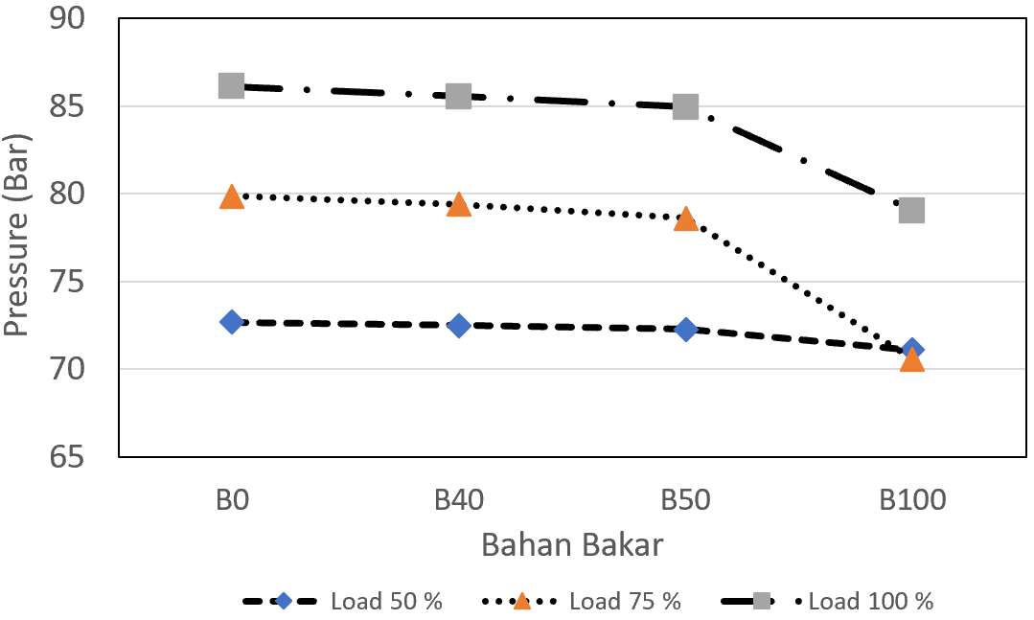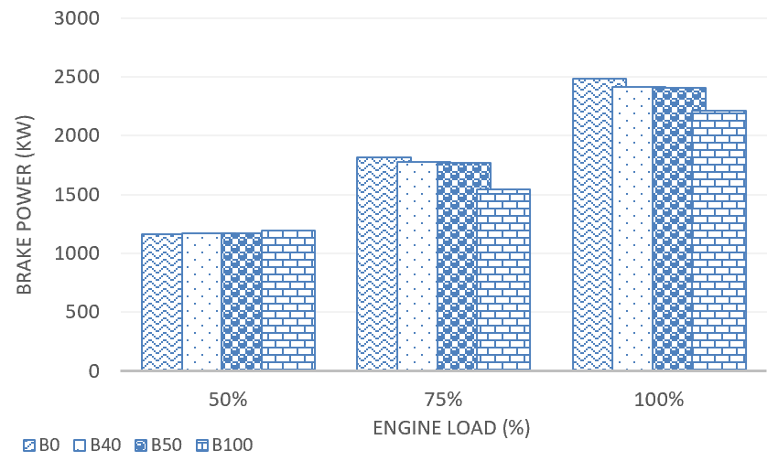
- (b)

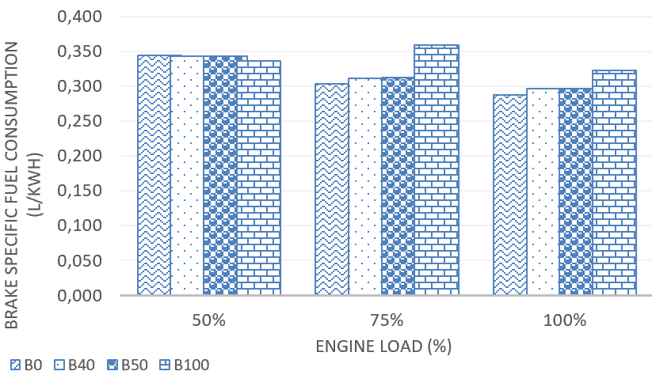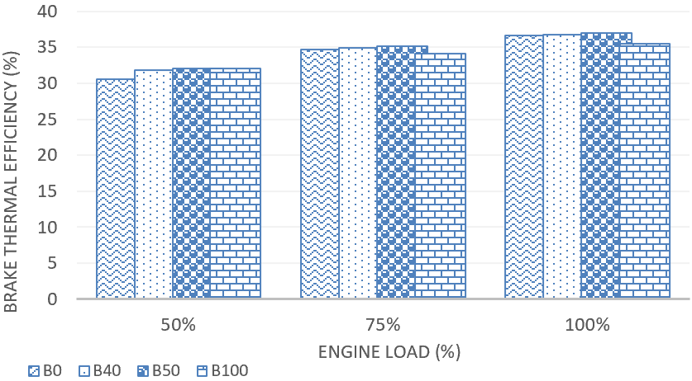
(c) (d)
Fig 2. Engine performance parameter: a Pressure; b) Brake power; c) BSFC; d) BTE

Heat Release Rate (HRR) and Ignition Delay
Heat Release Rate (HRR) is the rate at which heat energy is released during combustion and describes the intensity of combustion. At 100 percent load, the peak HRR for B0 reached 9.98 kJ/°CA, followed by B40 at 18.96 kJ/°CA, B50 at 17.44 kJ/°CA, and B100 at 10.99 kJ/°CA. The increase in HRR in B40 and B50 shows that the oxygen content in biodiesel helps accelerate the fuel oxidation process in the premixed combustion phase. The combustion duration (time from SOC to end of combustion) in B100 is longer than in B0, suggesting that different viscosity and evaporation characteristics of biodiesel affect the combustion process. Ignition delay (ID) is analyzed based on the time interval between Start of Injection (SOI) and Start of Combustion (SOC). At 100 percent load, B0 shows an ignition delay of about 7°CA, B40 of 11°CA, B50 of 10°CA, and B100 of 9°CA. These differences are influenced by the physical properties of the fuel, especially viscosity and volatility, as well as the different chemical kinetic mechanisms between fuel types.
The Effect of Biodiesel Variations on Exhaust Emissions
Exhaust emission analysis showed that the use of biodiesel variations had a significant influence on the formation of NOx and CO2 emissions. At 100 percent load, the highest NOx emissions were generated by B0 at 550 ppm, followed by B40 at 386 ppm, B50 at 364 ppm, and B100 at 348 ppm. The decrease in NOx emissions in B100 was directly correlated with a lower reduction in combustion temperature compared to other biodiesel variations. The formation of thermal NOx is greatly influenced by the high combustion temperature, so that the temperature decrease in B100 by 80 K results in a decrease in NOx emissions by 36 percent compared to B0. At 50 percent and 75 percent loads, the same trend was seen, with NOx emissions increasing in the intermediate biodiesel blend and decreasing in B100. CO2 emissions in B40 and B50 show an increase compared to B0, indicating that the oxygen content in biodiesel helps to improve the quality of combustion and carbon oxidation processes. The CO₂ value in B0 is 12.99 percent, increasing to 13.58 percent in B40 and 13.36 percent in B50, but decreasing to 11.57 percent in B100. CO emissions showed a significant decrease in B40 and B50 compared to B0 (0.82 percent), by 0.58 percent and 0.61 percent, respectively, indicating a more perfect combustion in the intermediate biodiesel blend.

Table 3. Effect of Biodiesel Variation on Exhaust Emissions at 100% Load
Emission Parameters | B0 | B40 | B50 | B100
NOx (mg/Nm³) | 550 | 386 | 364 | 348
CO₂ (%) | 12.99 | 13.58 | 13.36 | 11.57

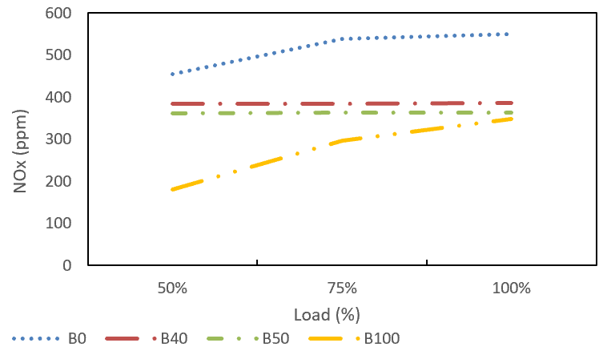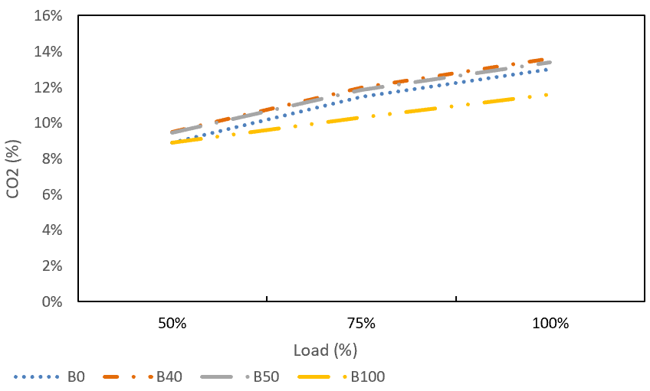

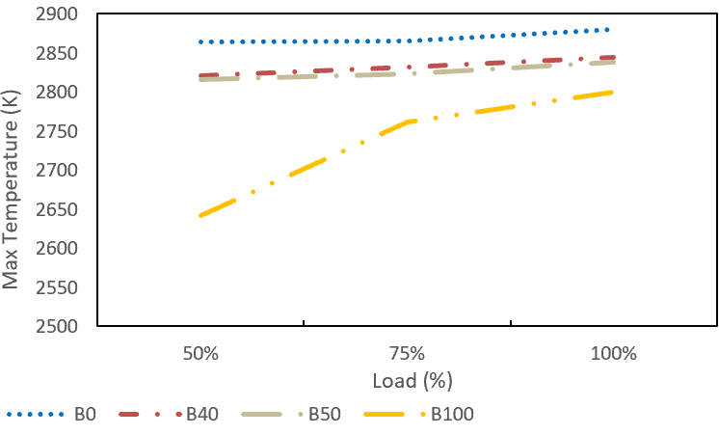
Fig 3. Maximum temperature & Gaseous emissions of different blending ratios at 100 % Load

CONCLUSION
This study used CFD simulation with ANSYS Forte to analyze the effect of the use of Biodiesel B0 to B100 on the performance of the SWD 9TM 410 diesel engine at various loading levels. The results of the model validation showed a good level of accuracy with a maximum pressure error of only 1.09 percent, proving that the CFD model is able to represent the actual combustion conditions of the engine. The use of biodiesel has a significant impact on engine performance, with the oxygen content in biodiesel helping the combustion process to be more perfect, but the lower calorific value causes a 6.4 percent reduction in power in B100 compared to B0. In terms of emissions, the increase in the biodiesel fraction shows a tendency to reduce NOx emissions by 36 percent in B100, inversely proportional to the combustion temperature. For further research, it is recommended: (1) to use a more detailed and specific chemical reaction mechanism for FAME biodiesel to make the prediction of emissions and ignition delay more accurate, (2) to conduct live experimental validation at various varied loads to increase confidence in the model, (3) develop simulations with more detailed turbulence and atomization models such as LES or wall-resolved turbulence models, (4) to assess the impact of long-term use of B40 Biodiesel on engine component durability, deposit formation, and lubricating oil degradation to ensure long-term operational reliability in diesel plants using renewable fuels, and (5) conduct sensitivity analysis of operating parameters such as injection pressure, injection time, and inlet air temperature for engine performance optimization.

REFERENCES
Ahmad, N., Khaerudin, Jupriyanto, Haryanto, A., & Putra, R. D. (2025). Contribution of B35 biodiesel to Indonesia’s renewable energy target and challenges for B40 implementation. MOTIVECTION: Journal of Mechanical, Electrical and Industrial Engineering, 7(3), 291–302.
An, H., Yang, W., Li, J., Maghbouli, A., Chua, K. J., & Chou, S. K. (2014). A numerical modeling on the emission characteristics of a diesel engine fueled by diesel and biodiesel blend fuels. Applied Energy, 130, 458–465.
Atadashi, I. M., Aroua, M. K., Abdul Aziz, A. R., & Sulaiman, N. M. N. (2012). Production of biodiesel using high free fatty acid feedstocks. Renewable and Sustainable Energy Reviews, 16(5), 3275–3285.
Bousbaa, H., Kaid, N., Alqahtani, S., Maatki, C., Naima, K., Menni, Y., & Kolsi, L. (2024). Prediction and simulation of biodiesel combustion in diesel engines: Evaluating physicochemical properties, performance, and emissions. Fire, 7(10), 364.
Cahyo, N., Sitanggang, R. B., Simareme, A. A., & Paryanto, P. (2023). Impact of crude palm oil on engine performance, emission product, deposit formation, and lubricating oil degradation of low-speed diesel engine: An experimental study. Results in Engineering, 18, 101156.
Chen, Y., Zhang, J., Zhang, Z., Zhong, W., Zhao, Z., & Hu, J. (2023). Utilization of renewable biodiesel blends with different proportions for the improvements of performance and emission characteristics of a diesel engine. Heliyon, 9(9), e19196.
Demirbas, A. (2008). Biodiesel: A realistic fuel alternative for diesel engines. Springer.
Ferguson, C. R., & Kirkpatrick, A. T. (2016). Internal combustion engines: Applied thermosciences (3rd ed.). John Wiley & Sons.
Ganesan, V. (2012). IC engines (4th ed.). Tata McGraw-Hill Education.
Heywood, J. B. (1988). Internal combustion engine fundamentals. McGraw-Hill.
Hoang, A. T. (2021). Prediction of the density and viscosity of biodiesel and the influence of biodiesel properties on a diesel engine fuel supply system. Journal of Marine Engineering & Technology, 20(5), 299–311.
Khan, M. M., Chatterjee, R., Hasnain, S. M. M., Giri, J., & Zairov, R. (2024). Effect of fuel injection parameters on the performance & emissions of biodiesel based CI engine – A review. Results in Engineering, 24, 103180.
Knothe, G., & Razon, L. F. (2017). Biodiesel fuels. Progress in Energy and Combustion Science, 58, 36–59.
Lapuerta, M., Armas, O., & Rodríguez-Fernández, J. (2008). Effect of biodiesel fuels on diesel engine emissions. Progress in Energy and Combustion Science, 34(2), 198–223.
Ma, F., & Hanna, M. A. (1999). Biodiesel production: A review. Bioresource Technology, 70(1), 1–15.
Mustak, R., & Rahman, K. M. (2025). Pilot fuel injection timing optimization of a natural gas–diesel dual-fuel CI engine using ANSYS Forte. Next Research, 2, 100619.

